What does this Vue error message mean? What causes it, and how do you fix it?

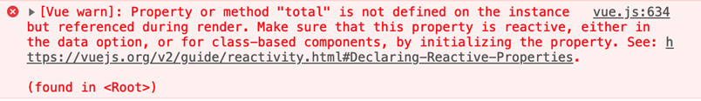

ANSWER”

This means that the variable (total) which exists in the template ( in the HTML), isn’t defined in the Vue app. it can be fixed by defining the variable (total) in the Vue app object where appropriate.

SCREEN SHOT FOR VUE DEVTOOLS

